DOCUMENT 19 — Professional & Organization Experience Spec
Visionary Internal · v1.0 · Stakeholder adapters over one SCM (Doc 06/07)

A professional is not a grown-up student and an organization is not a big teacher.
Vocabulary, evidence and permissions change; the intelligence underneath does not.

1. Professional experience
- Vocabulary lock: goal · capability · skill gap · project · portfolio · evidence.
Never board/class/chapter language in a personal career context.
- Journey: goal → capability map → gap → learning path → scenario practice →
build project → portfolio evidence → verifiable certificate / employer share.
- Practice = scenario & decision challenges (work simulations), not school quizzes.
- Certificate issued only on track mastery ≥0.95 + build evidence; verifiable link.
- Employer section renders only inside an explicit, consent-gated sharing boundary.

2. Organization experience
- Hierarchy: org → programs → cohorts → members; roles admin / billing / academic /
viewer under least privilege; deactivation + audit on every membership change.
- Analytics are aggregate-only; small-group suppression hides n<5; no individual
private doubts ever surface.
- Bulk onboarding: CSV 500 members ≤10 min, auto-enrol into cohorts.
- Curriculum: versioned map → review → approval; a draft can never distribute.
- Integrations: LMS sync (Fedena, iCloudEMS), whitelabel option, scoped exports.

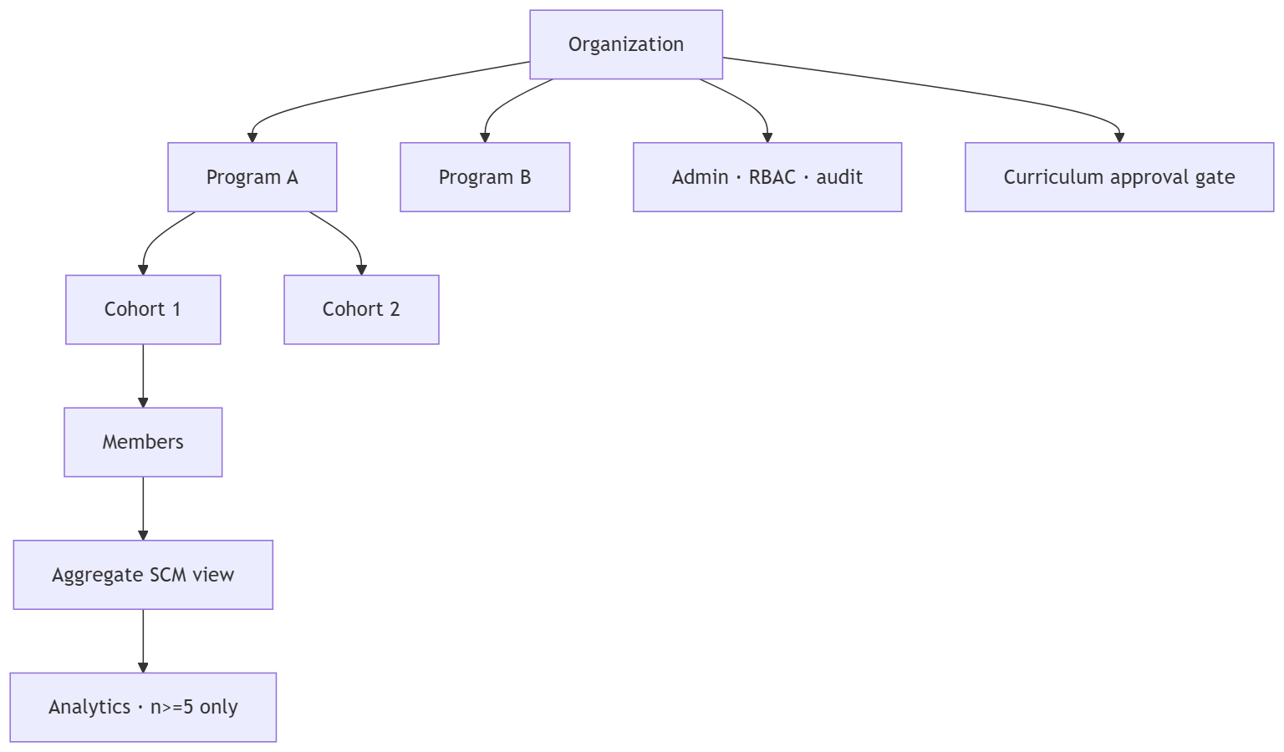

3. Shared rules
- Same 4-app shell; the role adapter swaps intent, data-view and LoRA (R7).
- Consent/invite pending, expired or revoked → status-only view, never cached report.
- Org reads aggregates; professional reads self; neither reads another person's raw SCM.

OKF
KF1 gap→project→evidence visible in one professional view · KF2 certificate verifiable
by a third party · KF3 org analytics suppress n<5 · KF4 bulk onboarding 500 ≤10 min ·
KF5 curriculum draft cannot distribute until approved.

